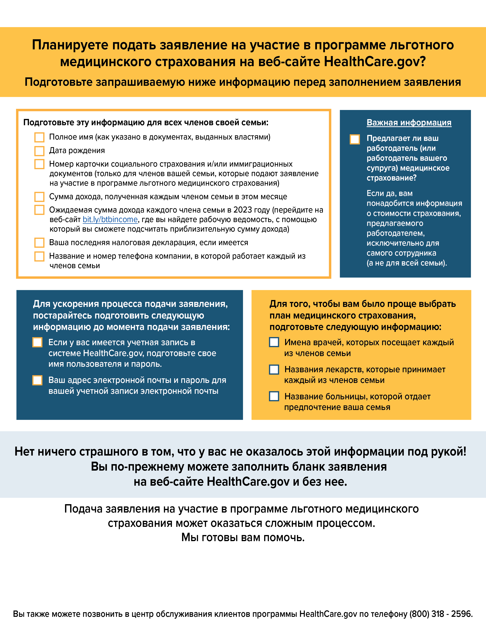

Add your organization’s logo here by clicking on “insert” in the menu bar then clicking on “pictures.” Delete this box if you don’t add your logo.

Add your organization’s name and contact information here.